# DECLARATION

I , **Aavula Avanthi Reddy** bearing rollno:**1084-21-516-008**, declare that the project work entitled “**Production of Bioethanol from Pontederia crassipes (Water Hyacinth)**” has been carried out by me under the supervision and guidance of **Dr.A.K.Sudhavani**. This project has not been submitted for any degree or examination in any other university. All the assistance taken during the course of the project and source of literature has been acknowledged.

**Aavula Avanthi Reddy**

**ACKNOWLEDGEMENT**

I convey my sincere gratitude to **Dr. A.K.Sudhavani**, **Sri Dharani Biotechs (Research and Training Institute)** Hyderabad for giving an opportunity and support to carry out my project work successfully.

With profound respect, I wish to express my deep sense of gratitude to **Dr. A.K.Sudhavani** for her valuable suggestions and encouragement during the course of my study.

I express my deepest gratitude to **Mrs.Pushpalatha**, Head of the Department and Faculty **Dr. A.K.SudhaVani, Mrs.Farheen Ayesha, Mr. Golla Kishore**, Department of Biotechnology, Government City College, for their prudent cooperation and for bestowing me with useful suggestions in the completion of my work.

I would like to thank my friends, classmates, and all those who helped medirectly or indirectly in this endeavor.

**Aavula Avanthi Reddy**

INDEX

# ABSTRACT

# HISTORY

# INTRODUCTION 1. MAIN SOURCES USED IN PRODUCTION OF BIOETHANOL

# WATER HYACINTH AND PRODUCTION OF BIOFUEL

# ADVANTAGES AND DISADVANTAGES

# REVIEW OF LITERATURE

# MATERIALS

# EQUIPMENTS

# METHODOLOGY 1. PRE-TREATMENT

# 2. ENYMATIC REACTION

# 3. FERMENTATION – ADDITION OF YEAST AND SUGAR

# 4. ESTIMATION OF SUGAR IN SAMPLES

# 5. DISTILATION

# 6. ESTIMATION OF ETHANOL BY POTASSIUM DICHROMATE METHOD [K2CR2O7]

# 7. TESTING AND OBSERVATION

# RESULT

# SCOPE

# CONCLUSION

# REFERENCE

ABSTRACT

ETHANOL OR ETHYL ALCOHOL (C2H5OH) IS A CLEAR COLOURLESS LIQUID; IT IS BIODEGRADABLE; LOW IN TOXICITY AND CAUSES LITTLE ENVIRONMENTAL POLLUTION IF SPILT. THE PRINCIPLE FUEL USED AS PETROL SUBSTITUTE FOR ROAD TRANSPORT VEHICLES IS BIETHANOL. BIOETHANOL FUEL IS MAINLY PRODUCED BY THE SUGAR FERMENTATION PROCESS. BIOETHANOL PRODUCTION FROM RENEWABLE BIOMASS HAS GAINED CONSIDERABLE ATTENTION ONE OF THE ALTERNATIVE BIOFUELS TO PARTIALLY REPLACE CONVENTIONAL FUEL FROM FOSSIL FUEL FEEDSTOCK. THE RAW MATERIAL (WATER HYACNTH AND GRASSES) UNDERGOES ACIDIC AND BASIC PRE-TREATMENTS FOR 24 HOURS. THE SAMPLES ARE WASHED WITH DISTILLED WATER FOLLOWED BY ADDITION OF YEAST AND DEXTROSE SUGAR ALONG WITH ENZYMES AND ALLOWED TO UNDERGO FERMENTATION FOR 20-40 DAYS. THE ETHANOL IS EXTRACTED FROM THE SAMPLES BY THE PROCESS OF DISTILLATION. SEVERAL PROBLEMS INCLUDING ENERGY INTENSIVE PRE-TREATMENT, LOW SUGAR YIELD DURING HYDROLYSIS AND LOW CONVERSION EFFICIENCY OF FERMENTTION OF SUGARS ARE AMONG THE MAJOR LIMITATIONS THAT AFFECTS THE FINAL BIOETHANOL YIELD. IN JUNE 2022, INDIA ACHIEVED AN AVERAGE BLENDING RAATE OF 10% ETHANOL IN PETROL. ACCORDING TO ICAR RESEARCH, INDIA’S ETHANOL PRODUCTION HAS TO BE INCREASED THREE TIMES ITS CURRENT LEVEL TO MEET THE TARGET OF 20% ETHANOL BLENDING BY 2025.

History

Water hyacinth (Eichornia crassipes), which is originated from Amazon basin (Barrett, 1989). This species was brought to mainland China in the 1930s. With its extremely high growth rate, this floating plant has infested many aquatic systems in 19 provinces of China. This is not an indigenous species but was introduced to India during the British colonial rule as an ornamental aquatic plant from South America. Ethanol's first use was to power an engine in 1826, and in 1876, Nicolaus Otto, the inventor of the modern four-cycle internal combustion engine, used ethanol to power an early engine. Ethanol also was used as a lighting fuel in the 1850s, but its use curtailed when it was taxed as liquor to help pay for the Civil War. In the 1970s, Brazil and the United States (US) started mass production of bioethanol grown from sugarcane and corn respectively. Current interest in bioethanol lies in production derived from lignocellulosic biomass. India initiated the use of ethanol as an automotive fuel in the year 2003. The Ministry of Petroleum and Natural Gas (MoPNG) issued a notification in September 2002 for mandatory blending of 5 % ethanol in 9 major sugar producing states and four union territories from 2003. In Bihar country's first ethanol plant was inaugurated in Purnea district in 2022.

INTRODUCTION

Bioethanol is a type of alcohol that is obtained from different types of plants rich in cellulose such as sugar cane, sugar beet, grapes, **water hyacinth**, rice straw, grasses or some grains such as corn. Biofuels are any fuels produced from biomass, such as organic waste materials and such fuels can have a significantly reduced ecological foot print compared to traditional fossil fuels. One such biofuel is bioethanol. Bioethanol is ethanol (an alcohol) produced through microbial fermentation of carbohydrates from plants or algae.

Bioethanol fuel is mainly produced by the sugar fermentation process. It can also be manufactured by the chemical process of reacting ethylene with steam. Although it is possible to cultivate these raw materials with the aim of using them directly for bioethanol production, this fuel can also be obtained from forestry residues and agricultural wastes.

Bioethanol is projected to be one of the determining renewable biofuels in the transportation sector and has already been introduced on a large scale in Brazil, USA and Europian countries. In the production and usage of second generation biofuels is low but the government is taking steps to enhance the production and usage. Many countries are developing renewable energy, including biofuel production.

Biomass wastes contain a complex mixture of carbohydrate polymers from the plan cell walls known as cellulose, hemi-cellulose and lignin. In order to produce sugars from the biomass, the biomass is pre-treated with acids or enzymes in order to reduce the size of the feedstock and to open up the plant structure.

The cellulose and the hemi cellulose portions are broken down (hydrolyzed) by enzymes or dilute acids into sucrose sugar that is then fermented into ethanol.

The principle fuel used as a petrol substitute for road transport vehicles is bioethanol.

There is also ongoing research and development into the use of municipal solid wastes to produce ethanol fuel.

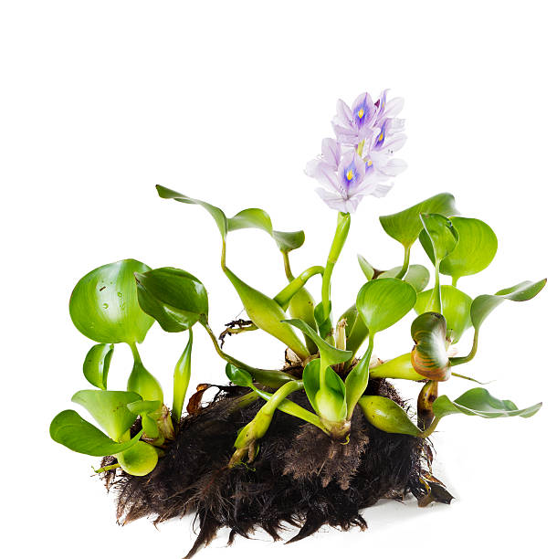

MAIN SOURCES USED IN

PRODUCTION OF BIOETHANOL

The main sources of sugar required to produce ethanol come from fuel or energy crops. These crops are grown specifically for energy use and include corn, sugarcane, wide variety of grasses, fruits, maize and wheat crops, waste straw, willow and popular trees, sawdust, reed canary grass, cord grasses, jerusalem artichoke, myscanthus and sorghum plants. On studying about the chemical composition of Water hyacinth i.e. it mainly comprise 57% cellulose, 25.6% hemicellulose, and 4.1% lignin, Water hyacinth yielded higher reducing sugar content (477 mg/3g in 3% sulfuric acid) than sugarcane leaves (419.33 mg/3g in 3% sulfuric acid). This could be as a result of the low lignin content of Water hyacinth compared to sugar cane leaves. Thus it sounds possible to produce Bioethanol from Water hyacinth that can ultimately contributes in the Reduce, Recycle and Reuse of raw waste material and can be used as:

* feed animals
* processed to improve the soil, as compost or biochar
* Bio-fertilizer in some organic agriculture practices.
* This plant is a good phytoremediation species, suggesting it has the ability to trap and remove toxic metabolites and harmful heavy metals from water.

WATER HYACINTH AND PRODUCTION OF BIOFUEL

* The trend of producing biodiesel by using plants that cannot be consumed is increasing. Since water hyacinth is non-edible and available in plenty it is very much suitable for biofuel production. The lignin content in biofuel is low, hence its properties like [cellulose](https://www.sciencedirect.com/topics/chemistry/cellulose) and hemicelluloses can be easily converted into fermentable sugar which can produce a large amount of biomass.
* Water hyacinth is considered as an attractive raw material for the bioenergy production including bioethanol, hydrogen, and biochar in many tropical regions of the world among various types of lignocellulosic substances.
* It listed as one of the world's most invasive and recalcitrant weeds because of its availability in large quantities, extraordinary adaptive ability, and remarkable growth rate.
* It grows at an extreme rapid rate and produces almost 2 tons of biomass per acre and its population doubles every 5–15 days which makes it a promising plant for the production of bioethanol on large scale.
* The water hyacinth was saccharified with diluted sulfuric acid and fermented to ethanol by yeast obtained from different hydrospheres.
* We found that the best conditions for water hyacinth hydrolysis were 1% (v/v) sulfuric acid at 121oC for 1hr.
* Water Hyacinth fulfills the need of an alternative source of energy.
* This method is simple process for economical bioconversion of water hyacinth to alcohol.
* This helps cleaning up the environment and provides the renewable resource of energy for future generation.

**ADVANTAGES OF BIOETHANOL**

Bioethanol has a number of advantages over conventional fuels. It comes from a renewable resource i.e. crops and not from a finite resource and the crops it derives from can grow well in the UK (like cereals, sugar beet and maize).

* + Another benefit over fossil fuels is the greenhouse gas emissions. The road transport network accounts for 22% (www.foodfen.org.uk) of all greenhouse gas emissions and through the use of bioethanol, some of these emissions will be reduced as the fuel crops absorb the CO2 they emit through growing.
  + Blending bioethanol with petrol will help extend the life of the UK’s diminishing oil supplies and ensure greater fuel security, avoiding heavy reliance on oil producing nations.
  + Bioethanol is also biodegradable and far less toxic that fossil fuels.

# DISADVANTAGES AND CONCERNS:

* Biodiversity – A large amount of arable land is required to grow crops. This could see some natural habitats destroyed including rainforests.
* The food V fuel debate – There is concern that due to the lucrative prices of bioethanol some farmers may sacrifice food crops for biofuel production which will increase food prices around the world.
* Carbon emissions – There is debate over the neutrality of bioethanol when all elements are taken into consideration including the cost of changing the land use of an area, transportation and the burning of the crop.

REVIEW OF LITERATURE

* In 1970’s, Brazil and the United states started mass production of bioethanol grown from sugar cane and corn respectively. Current interest in bioethanol lies in the production derived from lignocellulosic biomass.
* The concept of biofuel dates back to Rudolf Diesel who envisioned vegetable oil as a fuel source for his newly invented engine.
* Ethanol’s first use as to power an engine in 1826 and in 1876 Nicolaus Otto, the inventor of the modern four-cycle internal combustion engine, used ethanol to power an early engine.
* Today’s ethanol industry began in the 1970’s when the petroleum based fuels became expensive and environmental concerns involving leaded gasoline created a need of an octane.
* In 2005, the first renewable fuels standard (RFS) became law as part of the United States energy policy (Renewable Fuels Association 2005).
* In 2004, Logen (Canada) became the 1st company to produce 1 Million gal/year of cellulosic ethanol.
* In 2006 with an increase to seven and one half billion gallon by 2012.
* The energy Independence and Security Act of 2007 signed by President Bush requires renewable fuel usage to increase to 36 billion gallons annually by 2022.
* Major source of bio-ethanol in India is from molasses, by product of sugarcane. The bio-refinery plant in Assam aims to produce bioethanol from bamboo.
* The ongoing project by MINISTRY OF PETROLEUM AND NATURAL GAS by government of India is 2G Ethanol Project (2nd Generation).

MATERIALS AND METHODOLOGY

**1. Raw Materials or Samples used in the project for the production of Bioethanol are:**

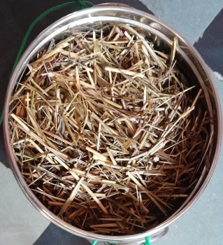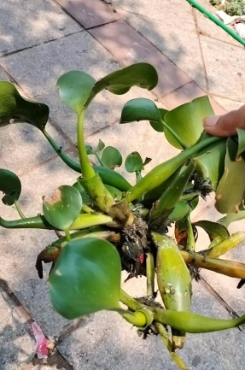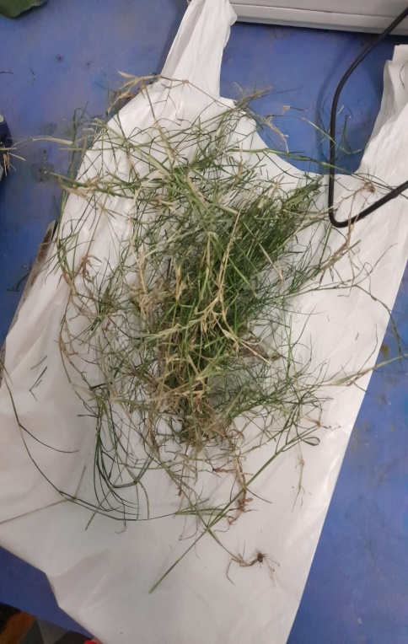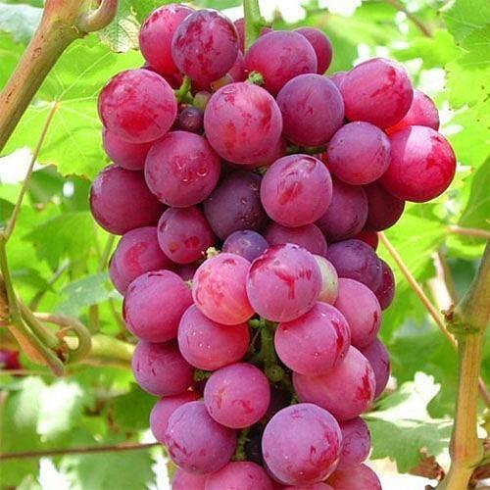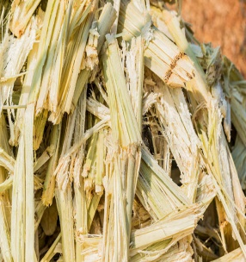   
The above raw materials are crushed or chopped into small pieces and weighed 10grams each.

1.Water Hyacinth 2. Scutch Grass 3. Dry Grass

4. Grapes 5. Bagasse

**2. Chemicals used in Pre-Treatment:**

* 1N HCl (3.6ml HCl + 100ml H2O)
* 1N NaOH (400mg NaOH + 100ml H2O)

**3. Chemicals used in Estimation of Sugars:**

* 1gram of Sodium Potassium Tartarate + 100ml distilled H2O
* 1gram of DNS reagent + 100ml distilled H2O

**4. Chemicals used in Fermentation:**

7.0 grams of BAKER’S YEAST + 20 grams of DEXTROSE SUGAR + 100ml of lukewarm distilled H2O

* Add 3ml of above solution into each of the containers containing samples.

**5. Enzymes used in Enzymatic Treatment:**

* Pectinase
* Amylase
* Cellulase
* STOCK SOLUTION= 0.071 grams of enzyme + 100ml distilled H2O
* Add 3ml of above enzyme solutions into each conical flask containing samples.

**6. Chemicals used in Estimation of Ethanol:**

* 0.01 M Potassium Dichromate in 5M H2SO4 **:**

Dilute up to 250ml with distilled water (H2O)

100ml distilled + H2O 70ml H2SO4 + 0.75grams

* 5 grams of Potassium Iodide + 25ml Distilled H2O

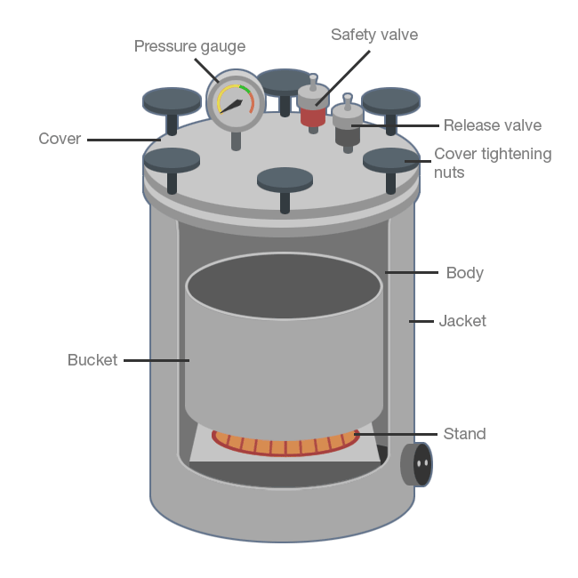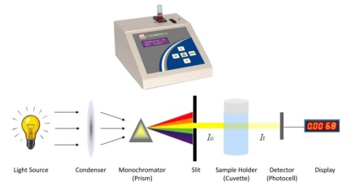**7. Equipments required:**

* AUTOCLAVE
* COLORIMETER
* WATER BATH

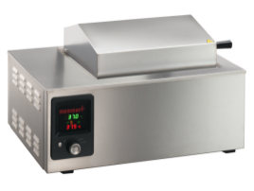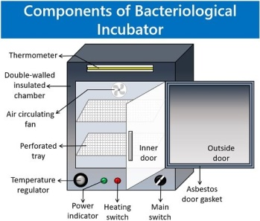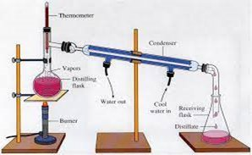

* INCUBATOR
* DISTILLATION SETUP

# METHODOLOGY:

# All the required glassware and necessary equipments are sterilized thoroughly before initiation of the production 1. PRE-TREATMENT:

# 10 grams of raw material each are divided into two sections as per Acidic and Basic pre-treatment into the conical flasks. 100ml of distilled water is adde to each conical flask.

# The chopped grasses, bagasse and leaves of water hyacinth are pre-treated with

# 1ml of 1N HCl (acidic) and 1ml of 1N NaOH (basic) and left for 24hrs.

# Grapes are crushed into pulp but are not pre-treated with any acidic or basic solutions.

# During the pretreatment process the compact structure of lignocellulosic is disrupted and cellulose fiber is exposed.

# Pretreatment of the lignocellulosic material is carried out to overcome recalcitrance through the combination of chemical and structural changes to the lignin and carbohydrates.

# After 24hrs of pretreatment the samples are washed three times with distilled water.

# 100ml of distilled water is added to conical flasks after the wash. Samples are autoclaved at 121°C temperature for 15 minutes at 151 lbs pressure. The mixture turns into a semisolid form.

# 2. ENYMATIC REACTION (ENZYMATIC HYDROLYSIS):

# Stock solution of enzymes are prepared.

# The raw materials or samples are treated with enzymes in order to break the Cellulosic, Hemi-cellulosic and Lignin layers by breaking down the amino acids and pectin which is often found in plant cell walls.

# 3ml of enzyme solution is added into the each conical flask which results in enzymatic treatment of samples.

|  |  |  |  |
| --- | --- | --- | --- |
| **S.NO** | **SAMPLES** | **PRE-TREATMENT** | **ENZYMES (PECTINASE,AMYLASE,CELLULASE)** |
| 1. | BAGASSE | ACIDIC | CELLULASE |
| 2. | BAGASSE | BASIC | CELLULASE |
| 3. | WATER HYACINTH | ACIDIC | CELLULASE |
| 4. | WATER HYACINTH | BASIC | CELLULASE |
| 5. | SCUTCH GRASS | ACIDIC | CELLULASE |
| 6. | SCUTCH GRASS | BASIC | CELLULASE |
| 7. | DRY GRASS | ACIDIC | ALL 3 ENZYMES |
| 8. | DRY GRASS | BASIC | ALL 3 ENZYMES |
| 9. | GRAPES | - | - |

# This is followed by the process of fermentation.

# 3. FERMENTATION:

# ADDITION OF YEAST AND SUGAR:

# 100ml of distilled water is heated over heat pan until it turns lukewarm.

# Yeast and Dextrose sugar is mixed well in the water and left for 20 mins to rest.

# After 20mins, 3ml of the solution mixture (Baker’s yeast and dextrose) is pipette out and poured into the conical flasks of each sample that includes grasses, bagasse, water hyacinth leaves and pulp of crushed grapes.

# It is allowed to undergo the process of fermentation with saccharomyces cerevisiae for 20-40 conservative days at 35-40°C temperature with agitation.

# Sugar undergoes fermentation in presence of enzyme and yeast to form Ethanol and Carbon dioxide. The chemical reaction is,

# C 6 H 12 O 6 (s) ENZYME 2 C 2 H 5 OH (l) + 2 CO2 (g) Glucose  Ethanol Carbon dioxide.

# 

# 4. ESTIMATION OF SUGAR IN SAMPLES:

* The sugar content is estimated by the DNS reagent method.
* The sugar content in all the samples is measured using colorimeter after the estimated fermentation period.
* The stock solutions of Sodium Potassium Tartarate and DNS Reagent are prepared and used for the estimation of sugar in the samples.
* Simultaneously the water bath is pre heated and kept ready.
* The samples are crushed and the liquid extract is used for estimation. 1ml of sample liquid is taken into the test tubes from each of the flasks respectively.
* To the above samples, 5ml of sodium potassium tartarate and 1ml of DNS reagent is added and heated in water bath for 10 mins.
* 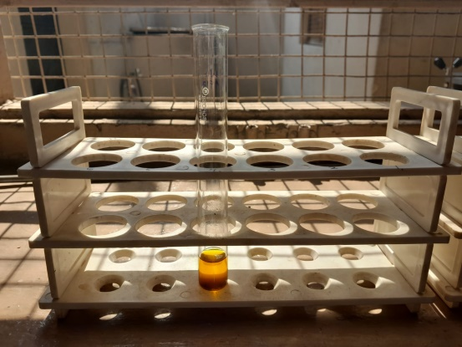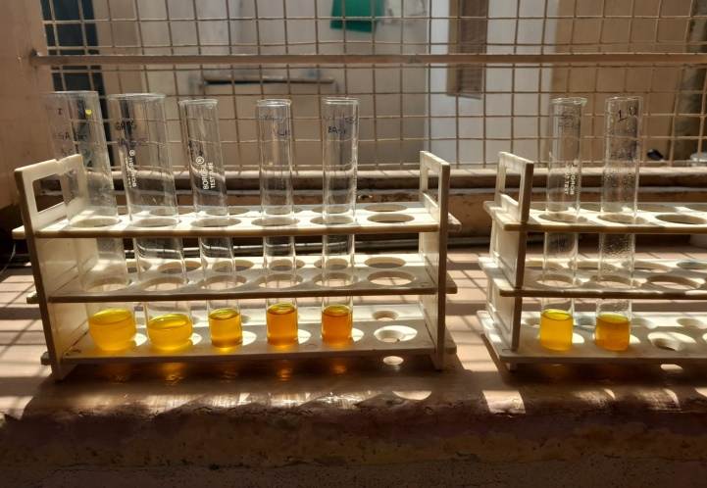We can observe the change in color of the sample mixture after 10min of heating. Allow it cool and measure the OD values in colorimeter against 540nm blank by taking 1ml of above sample solution in cuvette.

**SAMPLES BEFORE HEAT TREATING IN WATER BATH**

**SAMPLES AFTER HEAT TREATING IN WATER BATH**

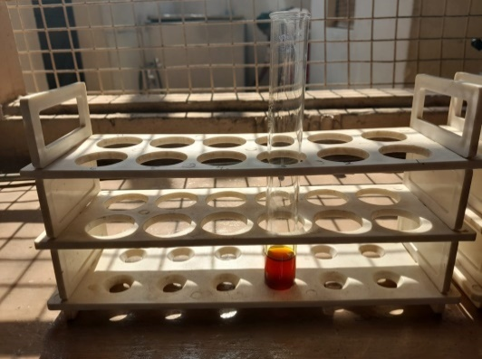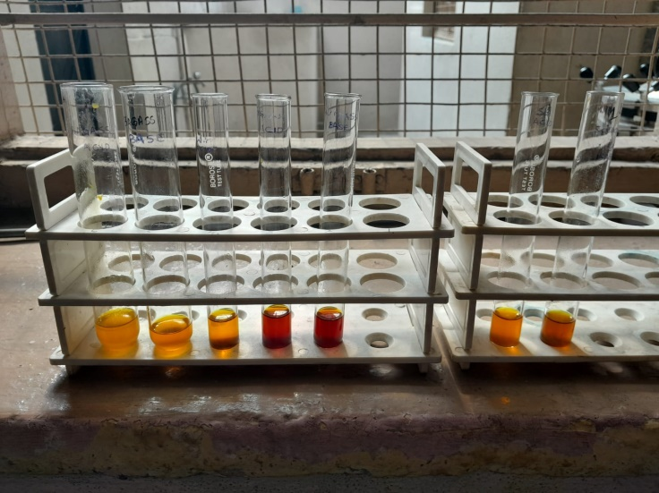(FROM LEFT TO RIGHT: BAGASSE – ACIDIC / BASIC, WATER HYACINTH – ACIDIC, DRY GRASS – ACIDIC/ BASIC, SCUTCH GRASS – ACIDIC / BASIC, WATER HYACINTH – BASIC RESPECTIVELY)

GRAPES SAMPLE BEFORE HEAT TREATMENT

GRAPES SAMPLE AFTER HEAT TREATMENT

|  |  |
| --- | --- |
| SAMPLE | OD VALUES OF SUGAR (nm) |
| 1. BAGASSE (ACIDIC) | 0.53 |
| 2. BAGASSE (BASIC) | 0.31 |
| 3. WATER HYACINTH (ACIDIC) | 0.37 |
| 4. WATER HYACINTH (BASIC) | 0.64 |
| 5. SCUTCH GRASS (ACIDIC) | 0.48 |
| 6. SCUTCH GRASS (BASIC) | 0.91 |
| 7. DRY GRASS (ACIDIC) | 0.58 |
| 8. DRY GRASS (BASIC) | 0.76 |
| 9. GRAPES | 0.26 |

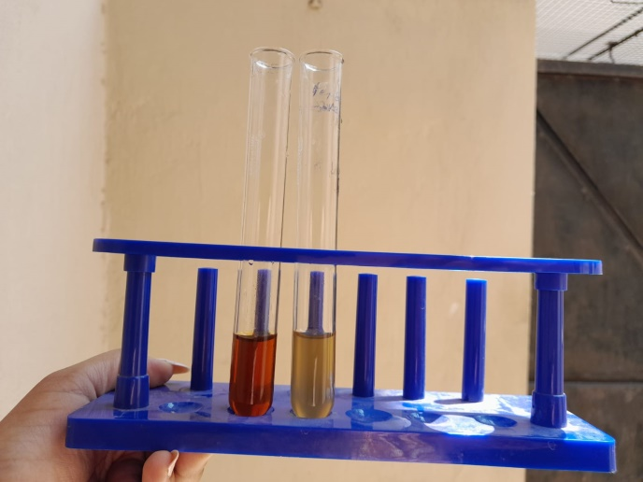

# 

# 6. DISTILATION:

# After the samples undergo the process of fermentation, ethanol produced is separated from them by the process of Simple Distillation / Column Distillation.

# Distillation, process involving the conversion of a liquid into vapour that is subsequently condensed back to liquid form.

# It is exemplified at its simplest when steam from a kettle becomes deposited as drops of distilled water on a cold surface.

# The distillation unit is all fit together, along with continues source of cold water for the condensation of vapours formed during boiling of liquid sample in round bottom flask, which is then collected in other container or conical flask.

# Distillation is done at 173°F (78.2°C).

# Each sample is allowed to undergo the process of distillation 4 times to get purified bioethanol from crude bioethanol.

# Time duration is 30mins, 20mins, 15mins and 10mins for 1st, 2nd, 3rd and 4th distillation respectively.

# After first distillation crude bioethanol is collected which subsequently purifies by the end of 4th distillation and we get a pure bioethanol from all the tested samples.

# After 3rd distillation of samples, benzene is added. To 91% of crude ethanol, 9% of benzene is added which results in 100% pure ethanol.

# The bioethanol collected from all the samples are then colorimetrically estimated by potassium dichromate method.

**DISTILLATION UNIT**

# 7. ESTIMATION OF ETHANOL BY POTASSIUM DICHROMATE METHOD [K2CR2O7]:

# 1ml of bioethanol is pipette out into test tube which was collected by distillation of each sample, to that 10ml of potassium dichromate solution is added.

# The solution mixture is incubated at 25°C for 24 hours.

# After incubation 1ml of potassium iodide is added and allowed to rest for 1min – 2mins.

# Take 1ml of the above sample solution in cuvette.

# Measure the OD values to estimate the concentrations of bioethanol from all samples using colorimeter against 578nm blank.

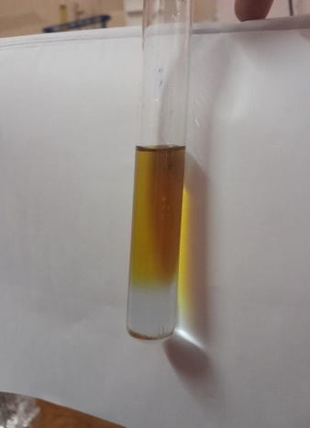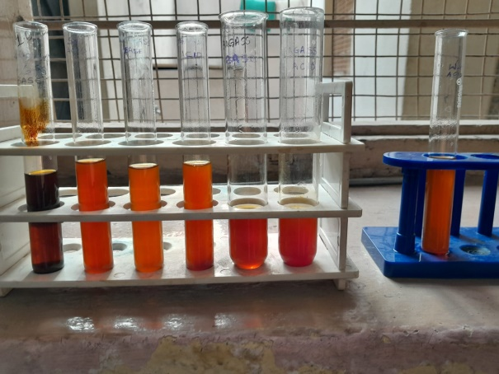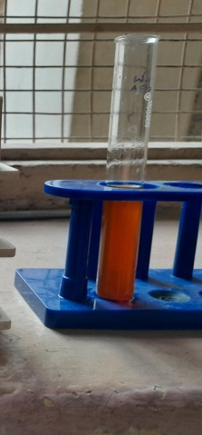**BIOETHANOL SAMPLES TREATED WITH POTASSIUM DICHROMATE AND POTASSIUM IODIDE FOR ESTIMATION OF ETHANOL CONCENTRATION**(SCUTCH GRASS – ACIDIC / BASIC, DRY GRASS – ACIDIC/ BASIC, BAGASSE – ACIDIC / BASIC, WATER HYACINTH – ACIDIC RESPECTIVELY)

GRAPES

WATER HYACINTH – BASIC

|  |  |
| --- | --- |
| SAMPLE | OD VALUES OF ETHANOL (nm) |
| 1. BAGASSE (ACIDIC) | 0.25 |
| 2. BAGASSE (BASIC) | 0.45 |
| 3. WATER HYACINTH (ACIDIC) | 0.75 |
| 4. WATER HYACINTH (BASIC) | 0.67 |
| 5. SCUTCH GRASS (ACIDIC) | 0.46 |
| 6. SCUTCH GRASS (BASIC) | 0.42 |
| 7. DRY GRASS (ACIDIC) | 0.27 |
| 8. DRY GRASS (BASIC) | 0.43 |
| 9. GRAPES | 0.08 |

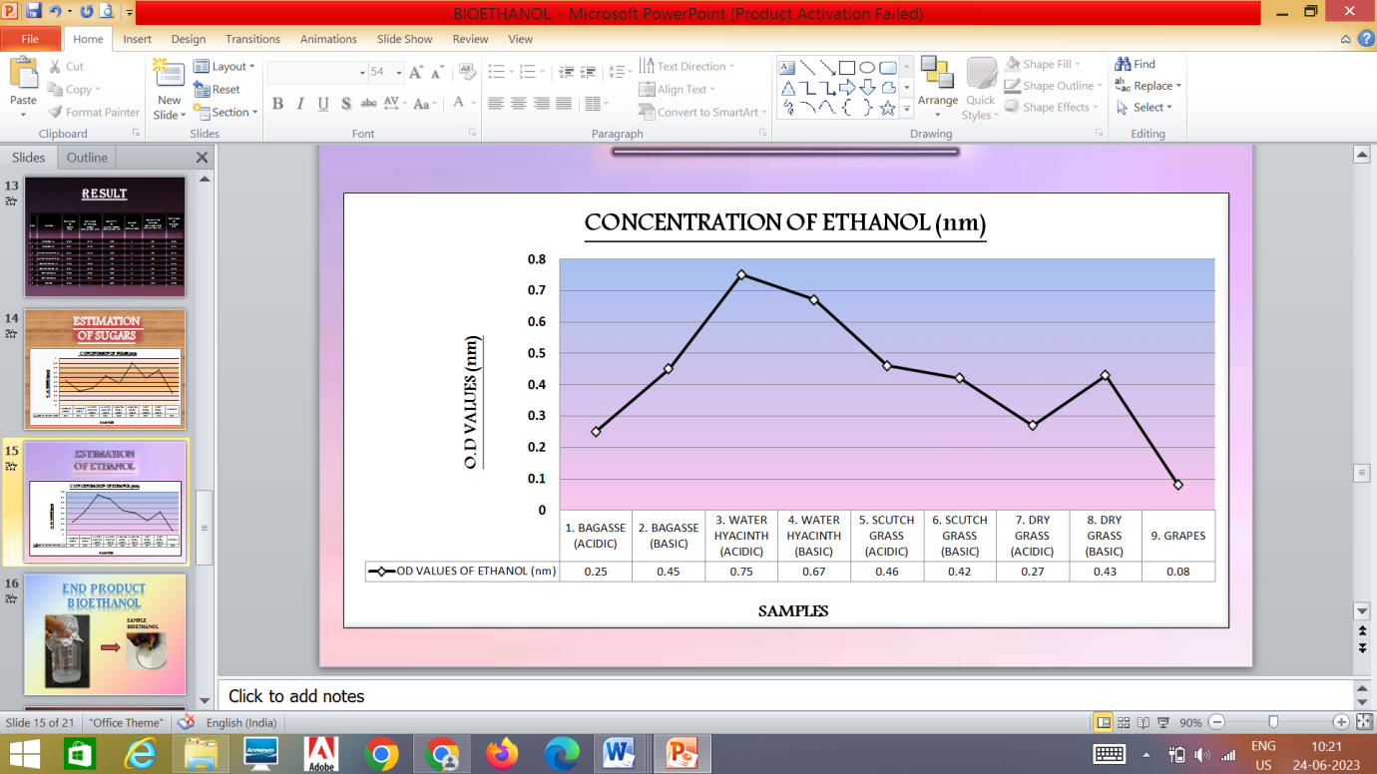

**8. TESTING AND OBSERVATION:**

* The bioethanol produced in lab from all the raw materials are fire tested as ethanol is flammable chemical component.
* It also gives a cooling sensation on skin when comes in contact with air as it is light weight chemical and can easily evaporate into the atmosphere.
* During estimation by potassium dichromate method to the lab produced ethanol when potassium dichromate is added, it loses its colour and within fraction of second the solution in test tube changes from yellow to colour less.
* To the above colorless solution when potassium iodide is added it gives lime yellow color which indicates the presence of ethanol in sample.

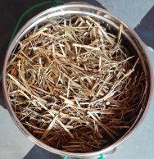

**SCHEMATIC REPRESENTATION OF PRODUCTION OF BIOETHANOL**

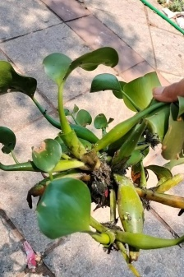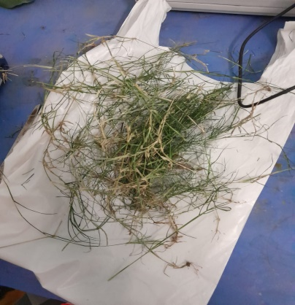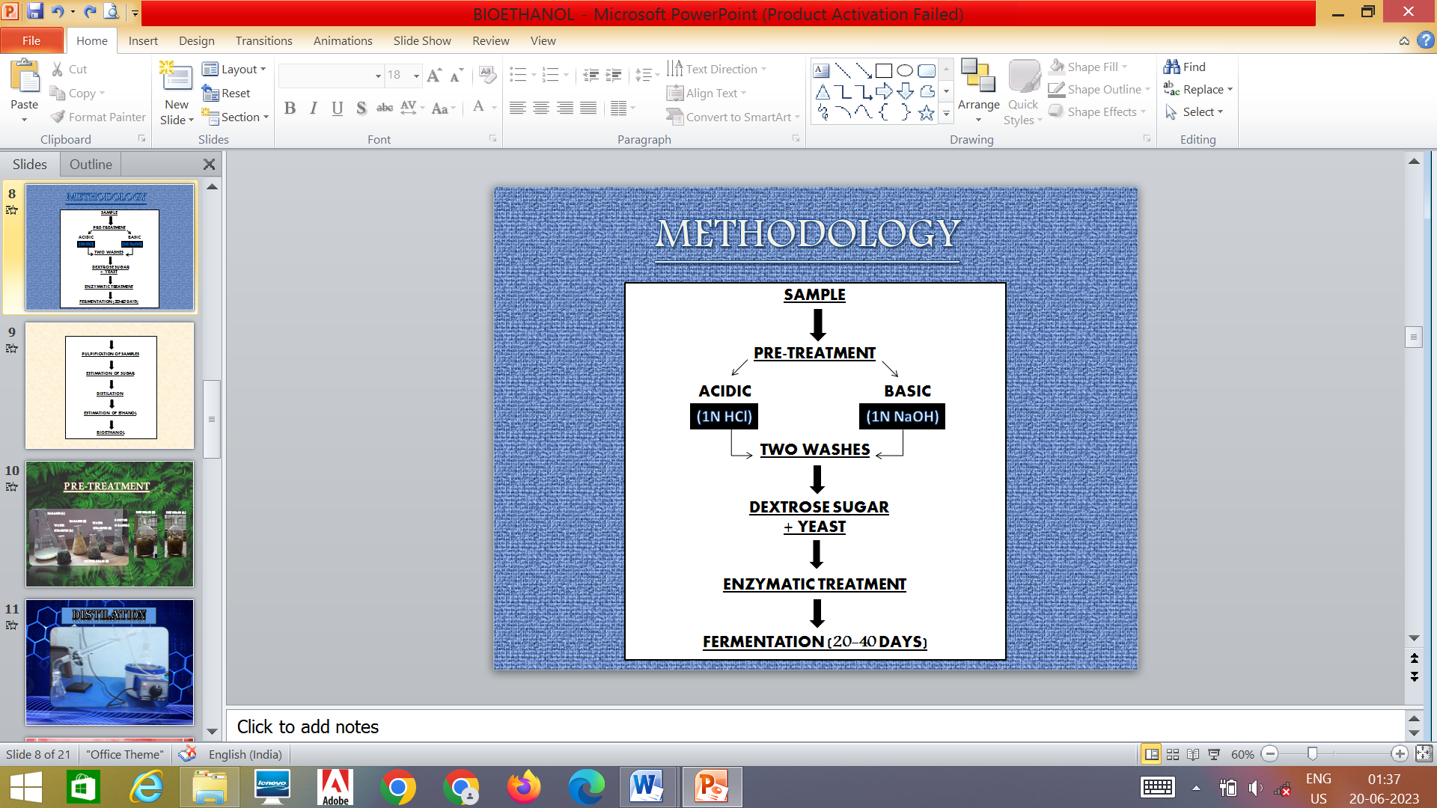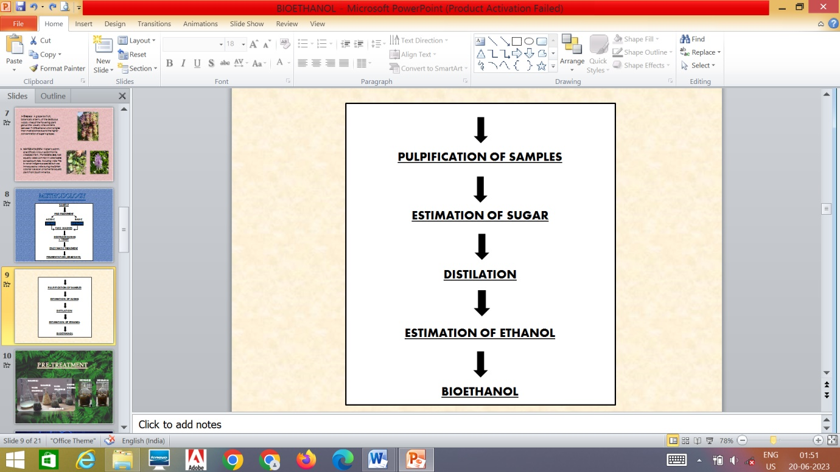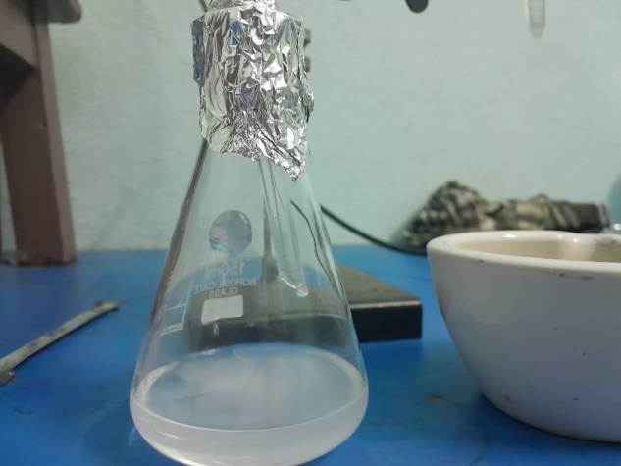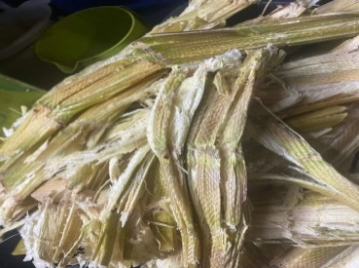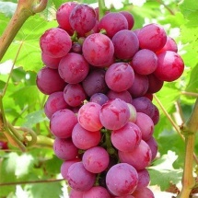

**RAW MATERIAL  
OR**

|  |  |  |  |  |  |  |
| --- | --- | --- | --- | --- | --- | --- |
| **S NO.** | **SAMPLES** | **O.D VALUES**  **OF ETHANOL**  **BEFORE**  **DISTILATION (nm)** | **QUANTITY**  **OF**  **SAMPLE BEFORE DISTILATION (ml)** | **NUMBER**  **OF**  **DISTILATIONS** | **QUANTITY**  **OF**  **SAMPLE BEFORE DISTILATION (ml)** | **O.D VALUES  OF  ETHANOL  (nm)** |
| 1. | BAGASSE (ACIDIC) | 0.73 | 100 | 4 | 100 | 0.25 |
| 2 | BAGASSE (BASIC) | 0.49-+ | 200 | 4 | 200 | 0.45 |
| 3 | WATER HYACINTH (ACIDIC) | 0.46 | 150 | 4 | 150 | 0.75 |
| 4 | WATER HYACINTH (BASIC) | 0.1 | 100 | 4 | 100 | 0.67 |
| 5 | SCUTCH GRASS (ACIDIC) | 0.66 | 75 | 4 | 75 | 0.46 |
| 6 | SCUTCH GRASS (BASIC) | 0.79 | 100 | 4 | 100 | 0.42 |
| 7 | DRY GRASS (ACIDIC) | 0.86 | 400 | 6 | 400 | 0.27 |
| 8 | DRY GRASS (BASIC) | 0.61 | 400 | 4 | 400 | 0.43 |
| 9 | GRAPES | 1 | 300 | 4 | 300 | 0.08 |

**RESULT**

The composition of grasses varies with species but it generally consists of 18% of lignin, 25.3% of hemicellulose and 29% to 50% of cellulose which makes it an alternative fuel source. Belal in 2008 highlighted the production of bioethanol from various biomasses to reduce both consumption of crude oil and reduces environmental pollution. The water hyacinth used in the present study mainly comprised 57% cellulose, 25.6% hemicellulose, and 4.1% lignin. Ethanol production varies with various pre-treatments. We have used acid and basic pre-treatment and pressure treatment. Hydrolysis of components like cellulose and hemicellulose into glucose and xylose are required for the production of ethanol. Phanital in 1982, MC ginnisital in 1983, hormeter in 1988 emphasize the use of various pre-treatments in ethanol production. In our study the sugar concentration ranged from 0.2 to 0.9 mg/ml and the ethanol concentration ranged from 0.2 to 0.7 with the pre-treatments.

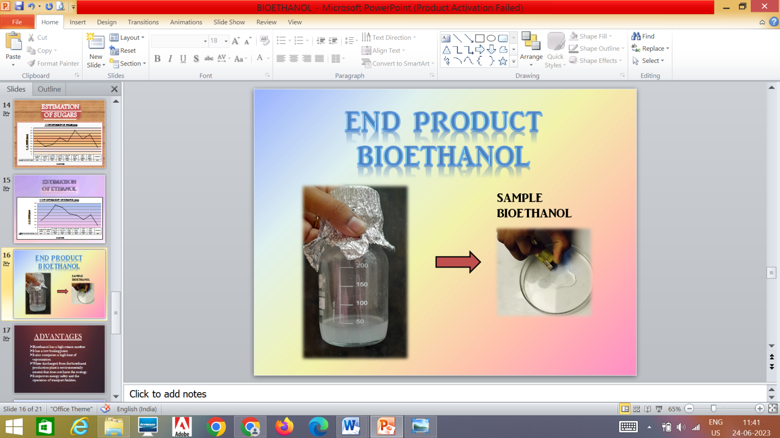

The higher amounts of monosaccharides and ethanol were obtained. The use of enzymes by default improves the production of bioethanol substantially. The use of grass, bagasse and water hyacinth for the production of bioethanol which are non-food alternatives for sweet sorghum which is a food crop. In the present study we report water hyacinth by the other treatments and fermentation is a good alternative for bioethanol production.

**FUTURE SCOPE**

The major source of energy comes from non-renewable fossil fuel that caused global warming, environmental degradation, and human health problems. The growing energy demands encourage scientists to explore low cost, environmental friendly and sustainable alternative energy sources. Bioethanol, as a clean, safe and renewable resource, is considered as a potential alternative to fossil fuels.

Bioethanol can significantly decarbonise our future energy needs, since its production can alleviate the negative impacts of greenhouse gas emissions from fossil fuels, and thus constrain global climate change.

The global bioethanol market was valued at USD 33.7 billion in 2020 and is projected to reach USD 64.8 billion by 2025, growing at a cagr 14.0% from 2020 to 2025. In India bioethanol blending will reach 12 per cent this year and meet the target of 25 per cent by 2025.

According to ICRA research, India's ethanol production has to be increased three times its current level to meet the target of 20% ethanol blending by 2025. According to the study, India's ethanol production in 2021 was roughly 335 crore litres. As a result, roughly 9% ethanol was blended into petrol.

**CONCLUSION**

Optimization of aquatic weed plant can reduce the water pollution as its growth reduces the oxygen level in water for aquatic animals. Water hyacinth and grasses used are the environmental wastes which are non-edible and it will not affect the food source of human’s. Finally, we can conclude that bioethanol is not only used as a transportation fuel but also as a fuel additive. The production of ethanol from edible and inedible sources provides opportunities to produce alternative transportation fuels.

Bioethanol is a fossil fuel that can be produced from Water hyacinth which is one of the world's worst aquatic weeds. This reduces greenhouse gases emission, waste weed plant can be turned into useful source and is cost-effective i.e. it is beneficial from an economic and environmental point of view.

The biofuel industry needs to combine integrated production technology and must produce value-added by-products. As a conventional invasive weed, water hyacinth proved its feasibility for bioethanol energy production.

# BIBLIOGRAPHY

**REFERENCES:**

1. Elsayed B. Belal (Bioethanol production from rice straw residues), 2013, Brazilian Journal of microbiology 44,1,225-234
2. Talebnia F, Karakashev D., angelida I, Production of bioethanol from wheat straw. An overview on pre-treatment, hydrolysis and fermentation, bio resources technology, 2010; 101; 4744-4753.
3. Vlasenko EY, Ding H, Labavitch J M, shoemaker S P, Enzymic hydrolysis of pretreated rice straw. Bioresources Technology, 1977, 59 (2&3) : 109-119.
4. Balat M, Balat H,Oz C: process in bioethanol processing, prog Energy Combust sci 2008,4:551-573
5. Zhao X, Cheng K, Liu D: organosolv pretreatment of lignocellosic biomass for enzymatic hydrolysis. Appl Microbial biotechnol 2009, 82:815-827.
6. Miller Gl: use of dinitrosalicylic acid reagent for determination of reducing sugar Anal Chem 1959, 13:426-428.
7. Berg, J.;Biochemistry, sixth ed. Freemantle and Company, London, 2007.
8. Chum, H. L.; Overend, R. P.; Fuel Processing Technology, 2001, 71, 187-195.
9. De Vasconcelos, J. N.; Lopes, C. E.; de França, F. P.; International Sugar Journal, 1998, 100, 73-75.
10. Gao, C.; Fleet, G. H; Journal of Applied Bacteriology, 1988, 65, 405– 410.
11. Jennings, D.H.; The physiology of Fungal Nutrition. Cambridge University Press, Cambridge, 1995, 392-394.

**Can**

1. Kumar, P.; Barrett, D. M.; Delwiche, M. J.; Stroeve, P.;Industrial and Engineering Chemistry Research,2009, 48, 3713–3729.
2. Lucero, P.; Pen˜alver, E.; Moreno, E.; Lagunas, R.;Applied and Environmental Microbiology,2000, 66
3. Mc Meckin, T. A.; Olley, J.;Ratkwsky, D. A.; Ross, T; International Journal Food Microbiology, 2002, 73, 395-407.
4. Ogawa Masami G. O., Usui I.Y.,Urano N., 92008). ‘Ethanol production from water hyacinth Eichhornia crassipes by yeast isolated from various hydrospheres’, African Journal of Microbiology Research, 2:110-113. (<https://www.researchgate.net/publication/215461607_Biofuel_production_from_Water_Hyacinth_using_various_yeasts>)
5. Sadashivam S. and Manickam A. (2004). ‘Biochemical Methods’, Chapter 1, Carbohydrates Pg. 10, 2nd edition. New Age Publisher, New Delhi.